**EXPERIMENT 1**

**AIM:** To design a static web page using HTML5 tags, lists, tables, forms, images, etc..

**THEORY:**

1. What is HTML?

HTML stands for Hyper Text Mark-up Language. HTML is the standard mark-up language for Web page. HTML elements are the building blocks of HTML pages. HTML elements are represented by <> tags.

All HTML documents must start with a document type declaration: <!DOCTYPE html>.

The HTML document itself begins with <html> and ends with </html>.

The visible part of the HTML document is between <body> and </body>.

1. Explain the different tags in HTML.

There are a lot of tags in HTML. Some of the basic tags are listed below:

* html tag: The <html> tag tells the browser that this is an HTML document. It tag represents the root of an HTML document. It is the container for all other HTML elements (except for the [<!DOCTYPE>](https://www.w3schools.com/tags/tag_doctype.asp) tag).
* head tag: The <head> element is a container for all the head elements. The <head> element can include a title for the document, scripts, styles, meta information, and more.
* title tag: The <title> tag is required in all HTML documents and it defines the title of the document.
* body tag: The <body> tag defines the document's body.The <body> element contains all the contents of an HTML document, such as text, hyperlinks, images, tables, lists, etc.

header tag: The <header> element represents a container for introductory content or a set of navigational links.A <header> element typically contains:

* one or more heading elements (<h1> - <h6>)
* logo or icon
* authorship information
* line break tag: The <br> tag inserts a single line break. The tag is an empty tag which means that it has no end tag.
* button tag: The <button> tag defines a clickable button. Inside a <button> element you can put content, like text or images. This is the difference between this element and buttons created with the <input> element.
* division tag: The <div> tag defines a division or a section in an HTML document. The <div> element is often used as a container for other HTML elements to style them with CSS or to perform certain tasks with JavaScript.
* Form tag: The <form> tag is used to create an HTML form for user input.
* image tag: The <img> tag defines an image in an HTML page. The <img> tag has two required attributes: src and alt.
* link tag: The <link> tag defines a link between a document and an external resource. It is used to link to external style sheets.
* list tag: The <li> tag defines a list item. The <li> tag is used in ordered lists([<ol>](https://www.w3schools.com/tags/tag_ol.asp)), unordered lists ([<ul>](https://www.w3schools.com/tags/tag_ul.asp)), and in menu lists ([<menu>](https://www.w3schools.com/tags/tag_menu.asp)).
* table tag: The <table> tag defines an HTML table. An HTML table consists of the <table> element and one or more [<tr>](https://www.w3schools.com/tags/tag_tr.asp), [<th>](https://www.w3schools.com/tags/tag_th.asp), and [<td>](https://www.w3schools.com/tags/tag_td.asp) elements. The <tr> element defines a table row, the <th> element defines a table header, and the <td> element defines a table cell.
* style tag: The <style> tag is used to define style information for an HTML document. Inside the <style> element you specify how HTML elements should render in a browser.

**SCREENSHOTS:**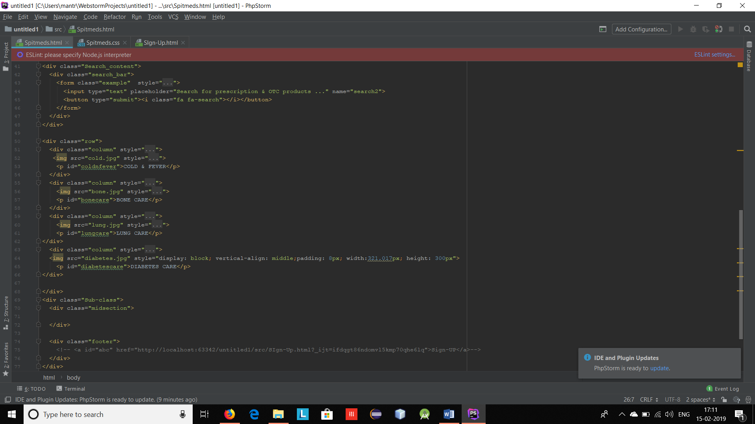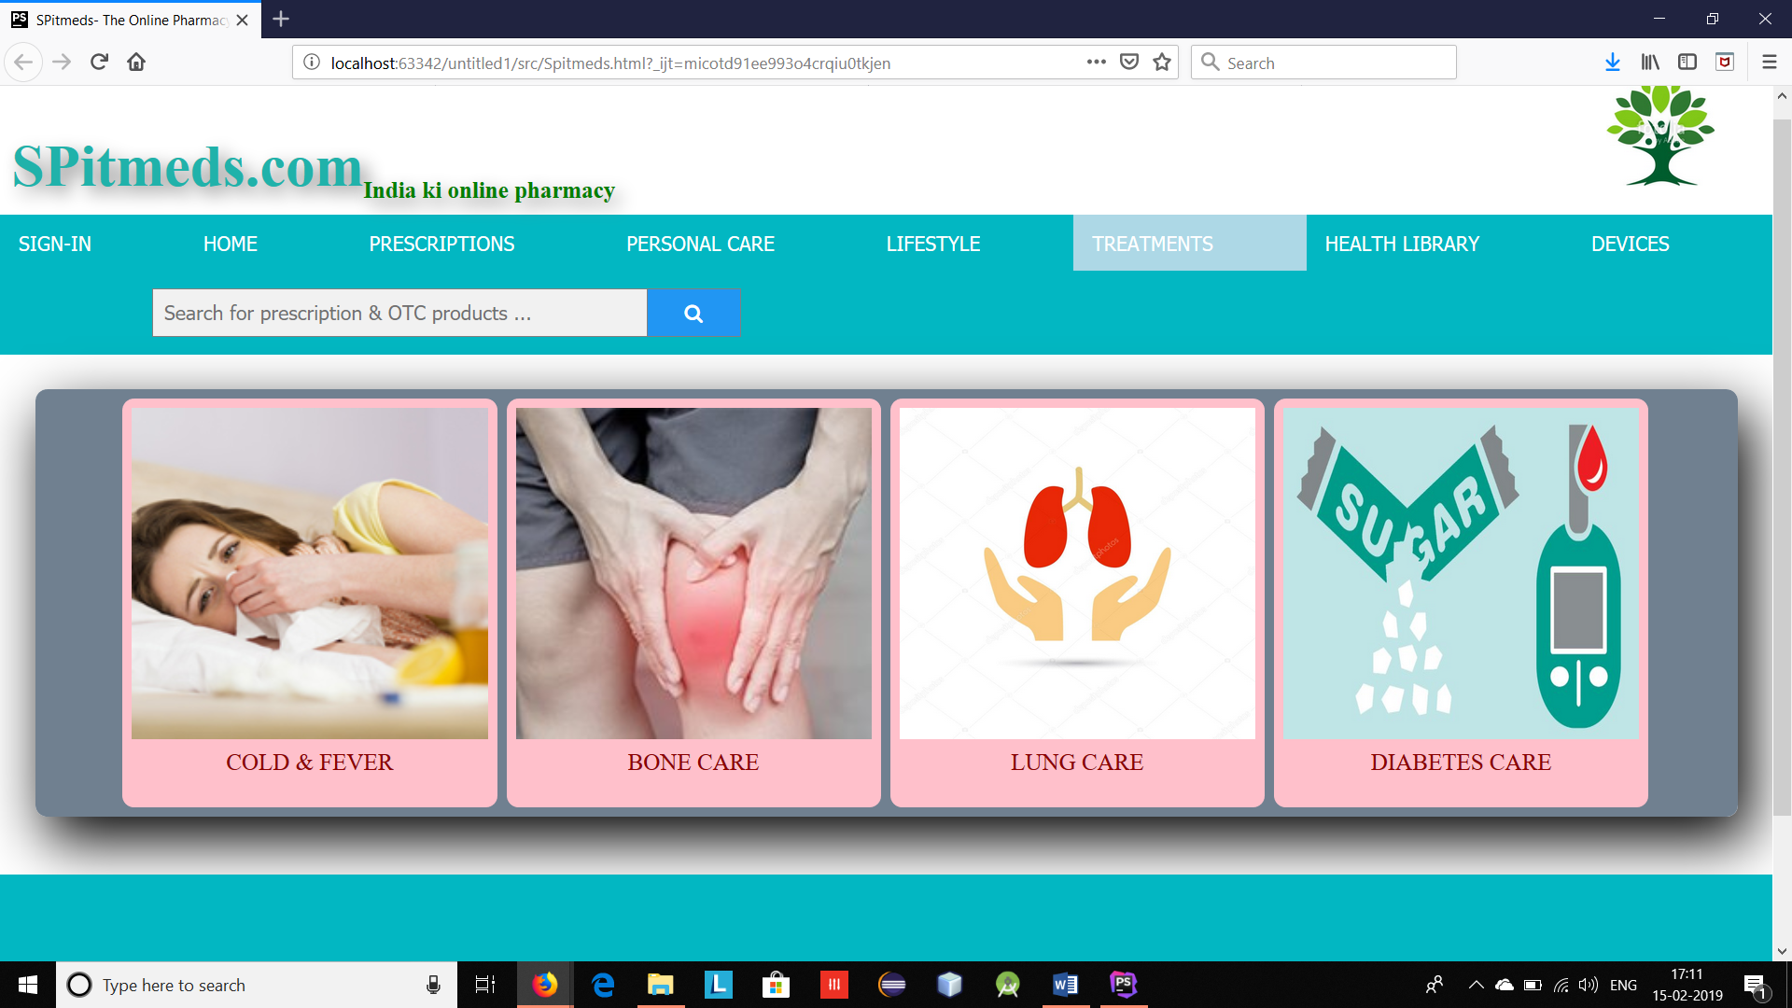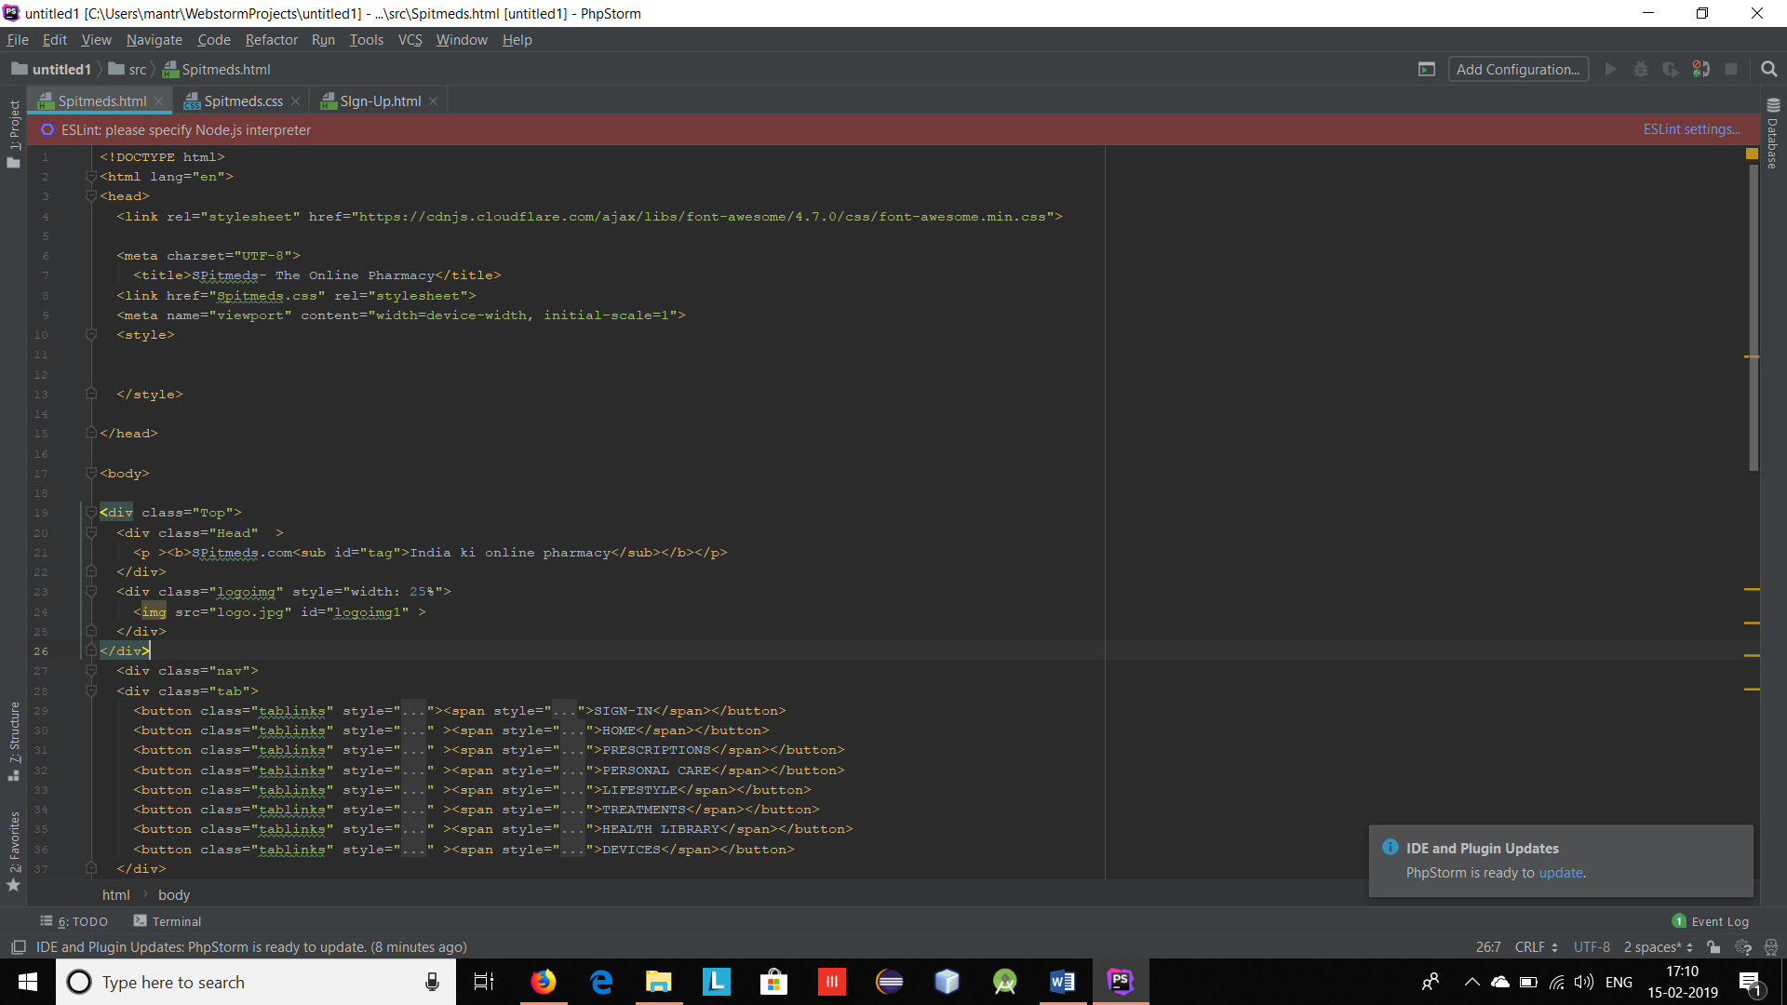

**CONCLUSION:** Got to know about HTML5 and were able to successfully implement a static webpage.